**Market Basket Insight's**

**Requirements** :

**Point of Sale (POS) Systems:**

These systems record transaction data, including the items purchased, their quantities, and prices. They often include barcode scanners to identify products.

**RFID (Radio-Frequency Identification):**

RFID tags on products and shopping carts can track the movement of items in real-time, helping retailers understand how products move through the store and which items are frequently picked up but not purchased

.**Security Cameras:**

Video surveillance can provide visual data to analyze customer behavior, such as how customers navigate the store, what products they interact with, and how long they spend in certain areas.

**Beacons:**

Bluetooth Low Energy (BLE) beacons can be used to track the location of customers in a store. This information can help retailers understand the customer's shopping journey.

**Wi-Fi Tracking:**

Retailers can monitor Wi-Fi signals from customers' mobile devices to track their movements and understand how they move through the store.

**Shopping Cart Sensors:**

Smart shopping carts equipped with sensors can detect which items are placed inside them and can even provide data on the path taken within the store.

**Mobile Apps and Online Platforms:**

Data from mobile apps and e-commerce websites can provide valuable insights into customer behavior, including browsing patterns, items added to shopping carts, and final purchases.

*Customer Loyalty Cards:*

Many retailers offer loyalty programs, and data from these cards can help track individual customer purchases and preferences.

**Checkout Surveys:**

Retailers can collect data through surveys or feedback forms during the checkout process to understand customer satisfaction, needs, and preferences

**Datasets:**

**Retail Sales Data:**

This includes data from grocery stores, department stores, or e-commerce platforms, showing what customers bought in various transactions.

**Point of Sale (POS) Data:**

These data sets often contain item-level details, allowing for a more granular analysis of customer behavior.

**Online Shopping Carts:**

E-commerce platforms can provide data on items added to shopping carts, wish lists, and final purchases.

**Transaction History:**

Historical transaction data for customers, showing their purchase history over time.

**Recommendation System Data:**

Data from recommendation systems like those used by Amazon or Netflix, which can show which items are frequently recommended together.

**Market Basket Survey Data:**

This includes data collected through surveys where customers are asked about their preferences and buying habits.

Analyzing market basket data sets can lead to insights such as product associations, cross-selling opportunities, and the identification of popular product combinations. These insights can be used to make data-driven decisions to improve sales, customer experience, and operational efficiency.

**MODEL RESULT:**

Association Rule: {Item A, Item B} => {Item C}Support: 0.05 (5% of transactions contain this combination)Confidence: 0.80 (80% of transactions with Item A and Item B also contain Item C)Lift: 1.25 (Item C is 1.25 times more likely to be bought when Item A and Item B are bought together)This result suggests that if a customer buys both Item A and Item B, there's an 80% chance they will also buy Item C, and this association is 1.25 times stronger than if the items were bought independently.These insights can be used for various purposes:

**Product Recommendations:**

If customers frequently buy certain items together, you can recommend those items together on your website or in your store.

**Inventory Management:**

Stock products that are often purchased together in close proximity to boost sales.

**Pricing Strategies:**

Offer discounts on complementary items to encourage bundle purchases.

Store Layout:

Place related items near each other in physical stores to increase the likelihood of cross-selling.

**Marketing Campaigns:**

Use the insights to design targeted marketing campaigns.

Keep in mind that the specific results will depend on the dataset, the algorithm, and the parameters used for analysis. It's essential to refine and validate these insights for your specific business context.

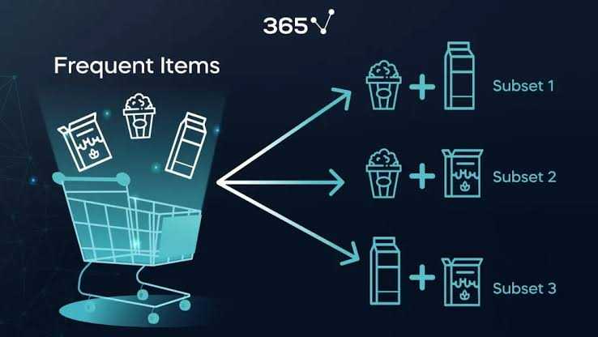

A system image is a comprehensive and exact duplicate of an entire computer's operating system, including the operating system itself, system files, installed applications, user data, and system configurations.

**TABULATION:**

In this example, we have various parameters and their corresponding readings. These readings represent data collected from different sensors or measurements in a given environment or system.

